Introduction: Getting Started with Jira Software
1. What is Jira Software?
Jira Software is a powerful project management and issue-tracking tool used by organizations to plan, track, monitor, and deliver work efficiently. It is widely adopted in Agile and DevOps environments and supports both Scrum and Kanban methodologies.
Developed by Atlassian, Jira enables teams to manage tasks, bugs, user stories, and project workflows in a centralized platform.

2. Why Jira is Important for Teams and Organizations
Jira is considered an industry standard because it provides:
- Centralized work tracking – All tasks and issues are managed in one place
- Agile project management – Supports Scrum, Kanban, and hybrid models
- Transparency & accountability – Clear ownership of work items
- Customizable workflows – Adaptable to different project needs
- Powerful reporting – Real-time progress and performance insights
- Scalability – Suitable for small teams to large enterprises
Real-World Usage
- Software development & testing
- Bug tracking and QA management
- IT service management
- Academic projects & internships
- Product and business process tracking

3. Jira Terminologies (Professional Notes)
3.1 Project
A Project is a container that holds all related issues, workflows, boards, and configurations.
Example:
Student Attendance Management System

3.2 Issue
An Issue is a single unit of work tracked in Jira.
Examples:
- Create login page
- Fix payment bug
- Test dashboard module

3.3 Issue Types
Issue Type | Description
Story | User requirement written from end-user perspective
Task | General work item
Bug | Defect or error
Epic | Large feature containing multiple stories

3.4 Workflow
A Workflow defines the lifecycle of an issue.
Typical Workflow:
To Do → In Progress → Testing → Done

3.5 Board
A Board visually displays issues and their status.
Board Type | Usage
Scrum Board | Sprint-based Agile projects
Kanban Board | Continuous workflow

3.6 Sprint
A Sprint is a fixed time-boxed iteration (usually 1–2 weeks) during which planned work is completed.

3.7 Backlog
The Backlog is a prioritized list of pending issues not yet started.

3.8 Assignee & Reporter
- Assignee – Person responsible for completing the issue
- Reporter – Person who created the issue

3.9 Status
Indicates the current stage of an issue.
Examples:
Open, In Progress, Testing, Done

3.10 Priority
Defines urgency of an issue.
Levels:
Highest, High, Medium, Low, Lowest

4. Hands-On Practice (Step-by-Step Lab)
Lab 1: Create a Jira Account
- Open browser → Go to jira.atlassian.com
- Sign up using email / Google
- Choose Jira Software
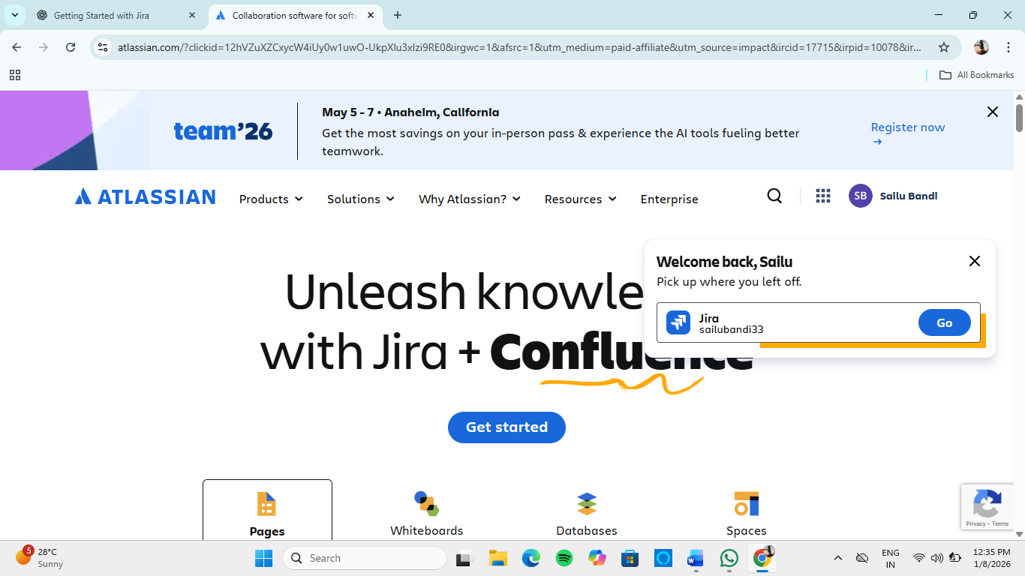

Lab 2: Create Your First Project
- Click Projects → Create Project
- Select Scrum (recommended for learning)
- Choose Company-managed project
- Enter:
  - Project Name: Learning Jira
  - Key: LJ
- Click Create
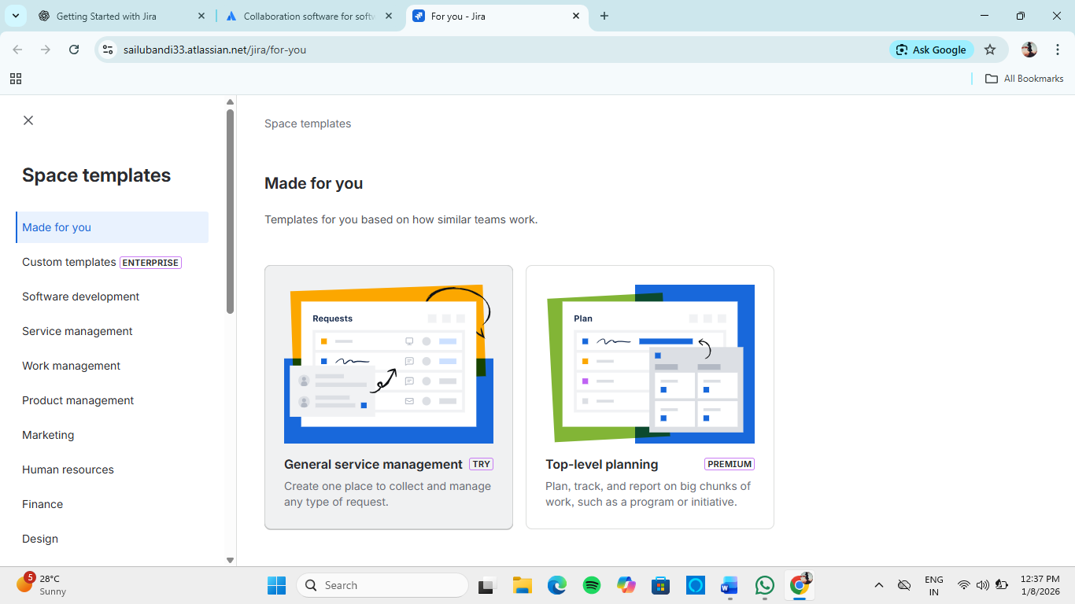
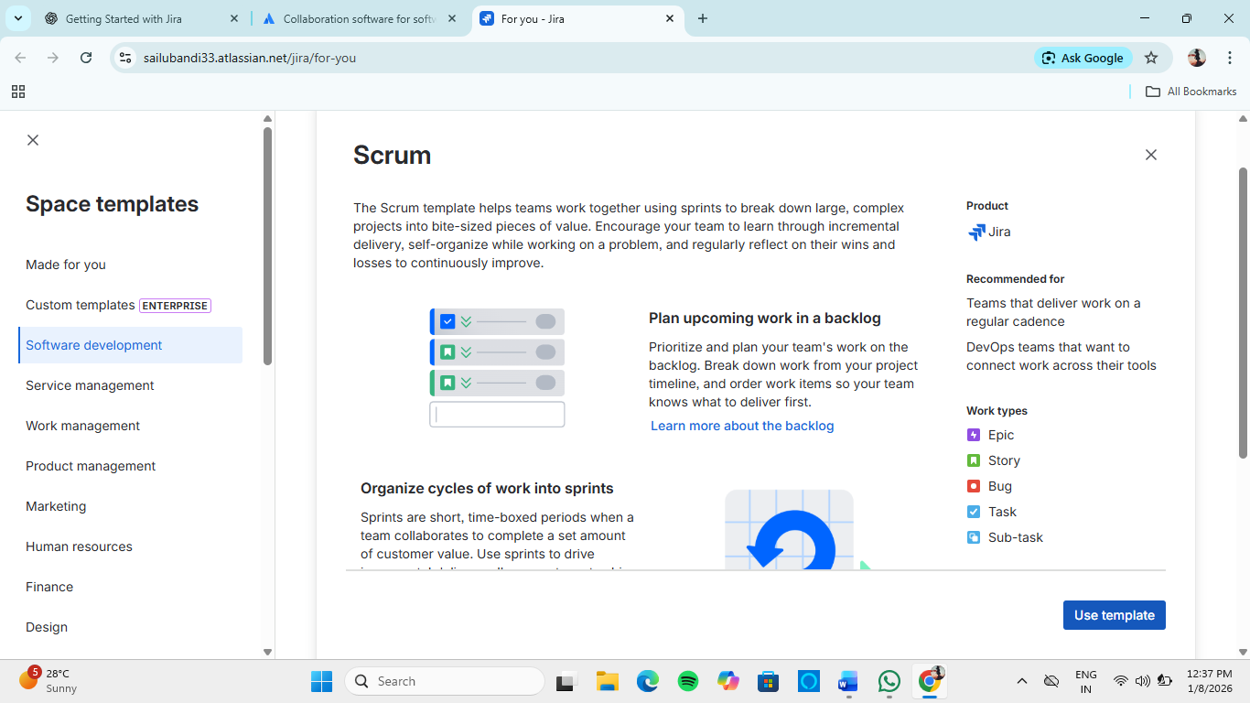
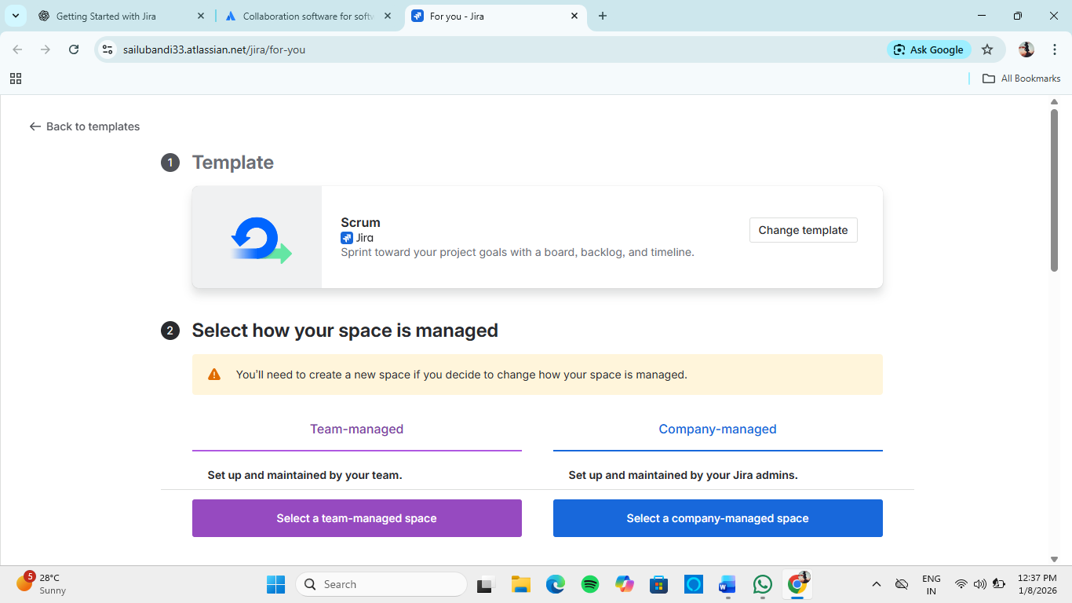
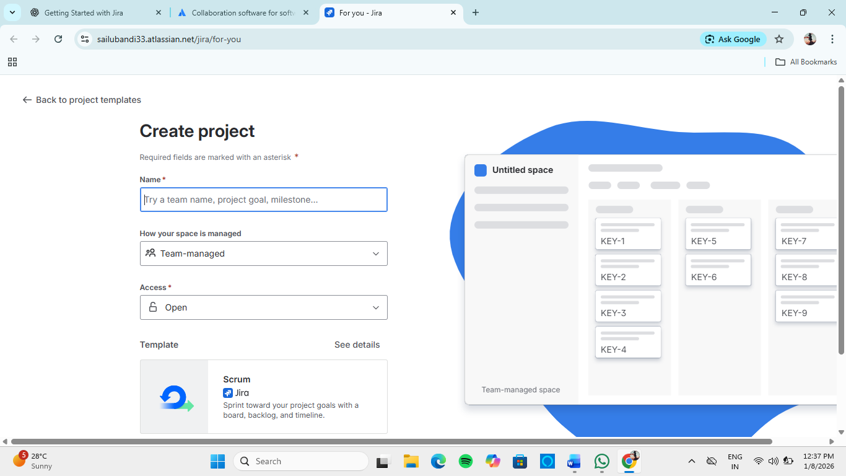

Lab 3: Create an Issue
- Click Create
- Select:
  - Issue Type: Task
  - Summary: Learn Jira Basics
  - Description: Understanding issues and workflows
- Assign to yourself
- Click Create

Lab 4: Move Issue Across Workflow
- Open the Board
- Drag issue:
  - To Do → In Progress → Done
- Observe status changes in real time

Lab 5: Create a Sprint
- Go to Backlog
- Click Create Sprint
- Add issues to sprint
- Click Start Sprint
- Set sprint duration (7 days)
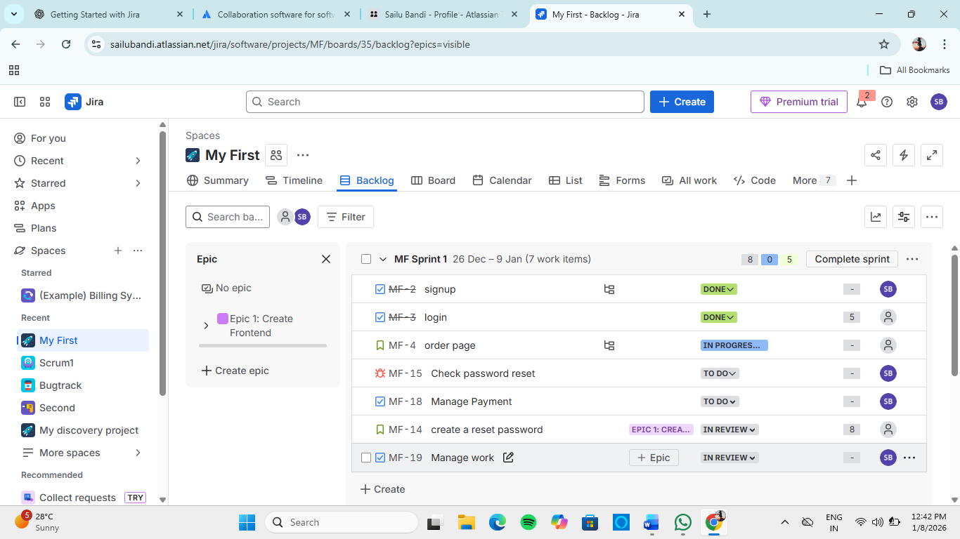
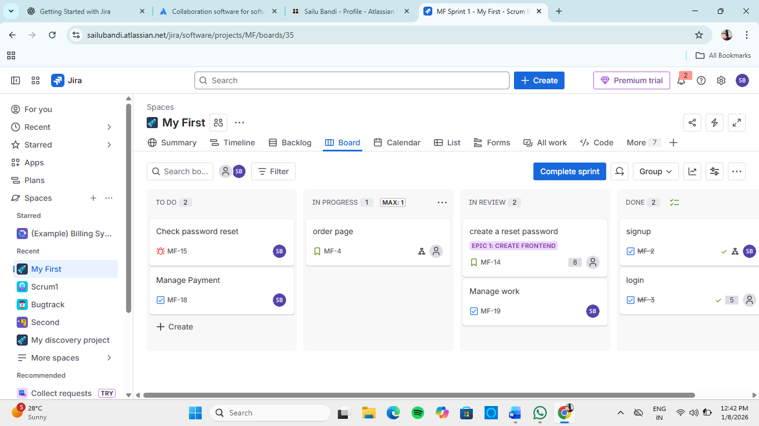

5. Key Learning Outcomes
After completing this module, the learner can:
- Understand Jira fundamentals and terminology
- Create projects, issues, and sprints
- Use boards to track work visually
- Apply Agile concepts practically

